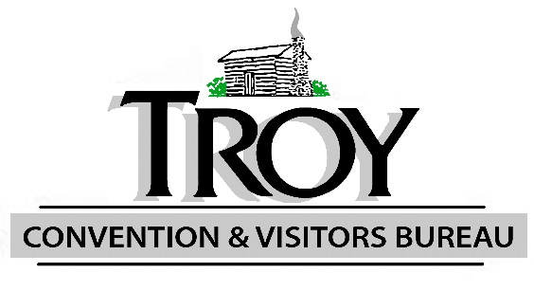
Troy Convention & Visitors Bureau
850 E. Cherry Street, Suite A, Troy, MO 63379
636-462-8769 • www.TroyCVB.com

BOARD OF DIRECTORS MEETING
Thursday March 12, 2020
8:45 am
Troy Area Chamber Conference Room

- Call to Order

- Review of all CVB Financials Year to Date - Balance Sheet, Profit Loss, Detailed Expense

- Marketing Plan 2020-2021

  - Troy Billboard
  - Flag Maintenance
  - Community News
  - Lincoln County Journal (possible other papers)
  - Focus on St Charles
  - List of potential ideas

- Update on Troy on The Move App

- Meeting scheduled for May to set budget

- Board Positions

  - Possible board options

- New Business

- Adjourn

