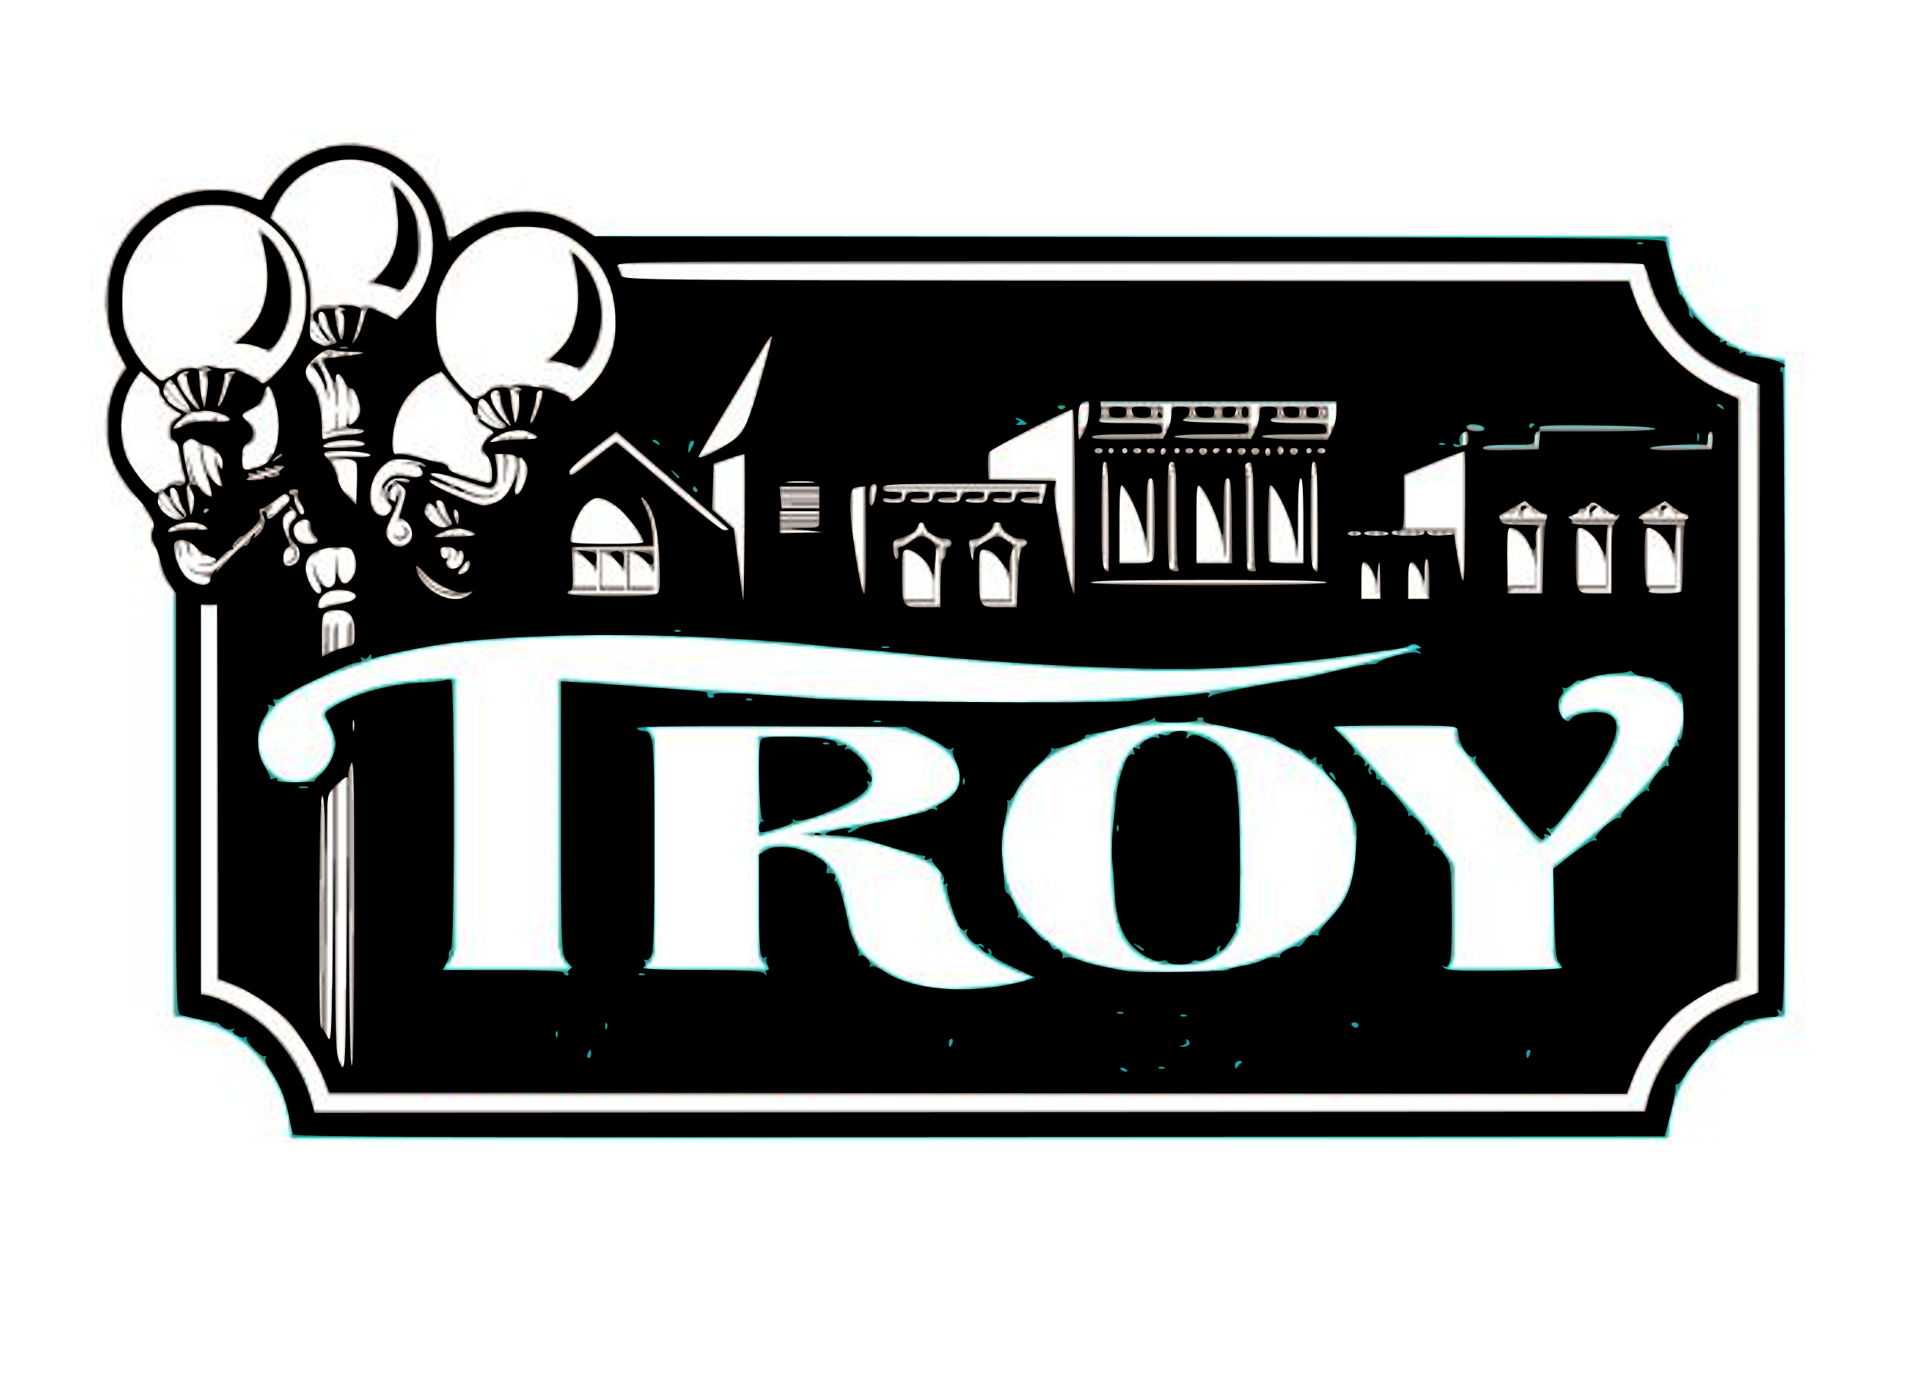
TROY HISTORIC DOWNTOWN BUSINESS ASSOCIATION
2019 VENDOR FORM
Company Name ________________________________________________________
Contact Name _________________________________________________________
Contact Number and Email _______________________________________________
Address ______________________________________________________________
Type of Merchandise/Food _______________________________________________
**THDBA ask that all merchants who are promoting their business or seeking leads but selling items at the event, please have a kid friendly activity at their booth.
FOOD VENDORS: CONTACT LINCOLN COUNTY HEALTH DEPT FOR PERMIT AT LEAST 30 DAYS PRIOR TO EVENT. CALL 636-528-7100 OR GO TO LCHDMO.ORG
Booth spaces: Approximately 10X10 (half a parking space). Outdoors. Not covered. No electric.
Vendor fee is $50 for Pumpkin Festival. OR You can sign up for Pumpkin Festival and Night of 1000 Stars for vendor fee of $80.
____ Pumpkin Festival- October 26, 2019 10am to 2pm $50.00
____ Pumpkin Festival AND Night of 1000 Stars- December 7, 2019 3pm to 8pm $80.00
Vendors will be limited to ONE per direct sales or parent organization.
Accepting completed applications with payment starting Monday, September 9th (8am)
Rhonda Schulte (Farmers Insurance Agency) 19 Ellis Ave, Troy. Mo 63379 (mail or drop off)
Questions? Send to thdbavendors@gmail.com
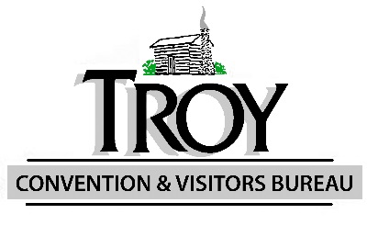
Checks paid to the order of - THDBA (Troy Historic Downtown Business Association)

